**Spring Data JPA Auditing with Spring Boot 2 and MySQL Example**

**author:**[**Ramesh Fadatare**](https://www.blogger.com/profile/14691512106162803120)

[**spring boot**](https://www.javaguides.net/search/label/Spring%20Boot?&max-results=10)

[**<< Back to Spring Boot Tutorial**](https://www.javaguides.net/p/spring-boot-tutorial.html)

In this article, we will discuss how can we configure JPA to automatically persist the *CreatedBy*, *CreatedDate*, *LastModifiedBy*, and *LastModifiedDate* columns for any entity. We will create a simple Spring Boot CRUD REST APIs and we implement auditing using spring data JPA.

In any business application, auditing simply means tracking and logging every change we do in our persisted records, which simply means tracking every insert, update, and delete operation and storing it. Basically, auditing helps us in maintaining history records, which can later help us in tracking user activities.

Instead of writing code manually on each save, update or delete operation why not we use third party library to do automatically for us. Spring Data provides sophisticated support to transparently keep track of who created or changed an entity and the point in time this happened. To benefit from that functionality you have to equip your entity classes with auditing metadata that can be defined either using annotations or by implementing an interface.

In this example, we will create a common generic *Auditable* abstract class with audit fields so that any entity can extend it to use auditing.

**Table of Contents**

1. What we’ll build
2. Tools and Technologies Used
3. Creating and Importing a Project
4. Packaging Structure
5. The pom.xml File
6. Configuring MySQL Database
7. Create Generic Auditable Class with Spring Data Annotations *@CreatedBy*, *@CreatedDate*, *@LastModifiedBy*, and *@LastModifiedDate*
8. Create a JPA Entity which extends *Auditable* Class - User.java
9. Auditing Author Using AuditorAware and Spring Security
10. Enable JPA Auditing by Using *@EnableJpaAuditing*
11. Create Spring Data JPA Repository - UserRepository.java
12. Creating UserController(Contains REST APIs)
13. Running the Application
14. Source code on GitHub

**1. What we’ll build**

We are building a simple Spring boot CRUD Rest APIs to demonstrate the usage of Spring Data JPA auditing with MySQL as a database.

**2. Tools and Technologies Used**

* Spring Boot - 2.0.4.RELEASE
* JDK - 1.8 or later
* Spring Framework - 5.0.8 RELEASE
* Hibernate - 5.2.17.Final
* Maven - 3.2+
* Spring Data JPA - 2.0.10 RELEASE
* IDE - Eclipse or Spring Tool Suite (STS)
* MYSQL - 5.1.47

**3. Creating and Importing a Project**

There are many ways to create a Spring Boot application. The simplest way is to use Spring Initializr at [**http://start.spring.io/**](http://start.spring.io/), which is an online Spring Boot application generator.

**[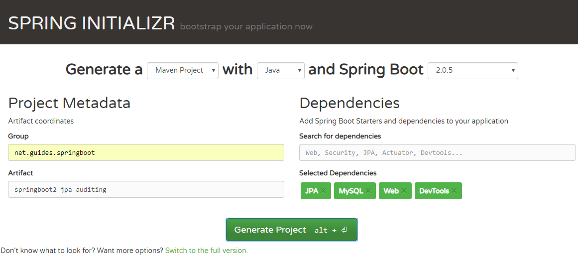](https://2.bp.blogspot.com/-WTLph1JtH4E/W6IW_JnX4RI/AAAAAAAAD5o/SQDeZ3T6giIsIxR7EUoBU3fjfVjp52jmgCLcBGAs/s1600/create-project.PNG)**

Look at the above diagram, we have specified following details:

* Generate: Maven Project
* Java Version: 1.8 (Default)
* Spring Boot:2.0.5
* Group: net.guides.springboot
* Artifact: springboot2-jpa-auditing
* Name: springboot2-jpa-auditing
* Package Name : net.guides.springboot.springboot2jpaauditing
* Packaging: jar (This is the default value)
* Dependencies: Web, JPA, MySQL, DevTools

Once, all the details are entered, click on Generate Project button will generate a spring boot project and downloads it. Next, Unzip the downloaded zip file and import it into your favorite IDE.

**4. Packaging Structure**

Following is the project structure for your reference -

**](https://4.bp.blogspot.com/-qEg3bVeb_QE/W6IXGaJyPWI/AAAAAAAAD5s/N4lkBbw730gFdyBwmxgax9Yh405U6M79ACLcBGAs/s1600/project-structure.PNG)**

**5. The pom.xml File**

<?xml version="1.0" encoding="UTF-8"?>

<project xmlns="http://maven.apache.org/POM/4.0.0" xmlns:xsi="http://www.w3.org/2001/XMLSchema-instance"

xsi:schemaLocation="http://maven.apache.org/POM/4.0.0 http://maven.apache.org/xsd/maven-4.0.0.xsd">

<modelVersion>4.0.0</modelVersion>

<groupId>net.guides.springboot</groupId>

<artifactId>springboot2-jpa-auditing</artifactId>

<version>0.0.1-SNAPSHOT</version>

<packaging>jar</packaging>

<name>springboot2-jpa-auditing</name>

<description>Demo project for Spring Boot</description>

<parent>

<groupId>org.springframework.boot</groupId>

<artifactId>spring-boot-starter-parent</artifactId>

<version>2.0.5.RELEASE</version>

<relativePath/> <!-- lookup parent from repository -->

</parent>

<properties>

<project.build.sourceEncoding>UTF-8</project.build.sourceEncoding>

<project.reporting.outputEncoding>UTF-8</project.reporting.outputEncoding>

<java.version>1.8</java.version>

</properties>

<dependencies>

<dependency>

<groupId>org.springframework.boot</groupId>

<artifactId>spring-boot-starter-data-jpa</artifactId>

</dependency>

<dependency>

<groupId>org.springframework.boot</groupId>

<artifactId>spring-boot-starter-web</artifactId>

</dependency>

<dependency>

<groupId>org.springframework.boot</groupId>

<artifactId>spring-boot-devtools</artifactId>

<scope>runtime</scope>

</dependency>

<dependency>

<groupId>mysql</groupId>

<artifactId>mysql-connector-java</artifactId>

<scope>runtime</scope>

</dependency>

<dependency>

<groupId>org.springframework.boot</groupId>

<artifactId>spring-boot-starter-test</artifactId>

<scope>test</scope>

</dependency>

</dependencies>

<build>

<plugins>

<plugin>

<groupId>org.springframework.boot</groupId>

<artifactId>spring-boot-maven-plugin</artifactId>

</plugin>

</plugins>

</build>

</project>

**6. Configuring MySQL Database**

Configure application.properties to connect to your *MySQL* database. Let's open an *application.properties* file and add following database configuration to it.

spring.datasource.url = jdbc:mysql://localhost:3306/users_database?useSSL=false

spring.datasource.username = root

spring.datasource.password = root

## Hibernate Properties

# The SQL dialect makes Hibernate generate better SQL for the chosen database

spring.jpa.properties.hibernate.dialect = org.hibernate.dialect.MySQL5InnoDBDialect

# Hibernate ddl auto (create, create-drop, validate, update)

spring.jpa.hibernate.ddl-auto = update

Change the above configuration such as JDBC URL, username and password as per your environment.

**7. Create Generic Auditable Class with Spring Data Annotations @CreatedBy, @CreatedDate, @LastModifiedBy, and @LastModifiedDate**

If you are auditing multiple entities then it is common practice to extract common fields with an abstract class and extend it. So instead of creating *createdBy*, *createdDate*, *lastModifiedBy*, and *lastModifiedDate* properties in each entity, we can move the *createdBy*, *createdDate*, *lastModifiedBy*, *lastModifiedDate* properties to a base class, Auditable, and annotate this base class with *@MappedSuperClass*. Later, we can use the *Auditable* class in other audited entities.

package net.guides.springboot.springboot2jpaauditing.audit;

import static javax.persistence.TemporalType.TIMESTAMP;

import java.util.Date;

import javax.persistence.EntityListeners;

import javax.persistence.MappedSuperclass;

import javax.persistence.Temporal;

import org.springframework.data.annotation.CreatedBy;

import org.springframework.data.annotation.CreatedDate;

import org.springframework.data.annotation.LastModifiedBy;

import org.springframework.data.annotation.LastModifiedDate;

import org.springframework.data.jpa.domain.support.AuditingEntityListener;

@MappedSuperclass

@EntityListeners(AuditingEntityListener.class)

public abstract class Auditable<U> {

@CreatedBy

protected U createdBy;

@CreatedDate

@Temporal(TIMESTAMP)

protected Date createdDate;

@LastModifiedBy

protected U lastModifiedBy;

@LastModifiedDate

@Temporal(TIMESTAMP)

protected Date lastModifiedDate;

public U getCreatedBy() {

return createdBy;

}

public void setCreatedBy(U createdBy) {

this.createdBy = createdBy;

}

public Date getCreatedDate() {

return createdDate;

}

public void setCreatedDate(Date createdDate) {

this.createdDate = createdDate;

}

public U getLastModifiedBy() {

return lastModifiedBy;

}

public void setLastModifiedBy(U lastModifiedBy) {

this.lastModifiedBy = lastModifiedBy;

}

public Date getLastModifiedDate() {

return lastModifiedDate;

}

public void setLastModifiedDate(Date lastModifiedDate) {

this.lastModifiedDate = lastModifiedDate;

}

}

**8. Create a JPA Entity which extends Auditable Class - User.java**

package net.guides.springboot.springboot2jpaauditing.model;

import javax.persistence.Column;

import javax.persistence.Entity;

import javax.persistence.EntityListeners;

import javax.persistence.GeneratedValue;

import javax.persistence.GenerationType;

import javax.persistence.Id;

import javax.persistence.Table;

import org.springframework.data.jpa.domain.support.AuditingEntityListener;

import net.guides.springboot.springboot2jpaauditing.audit.Auditable;

@Entity

@Table(name = "users")

@EntityListeners(AuditingEntityListener.class)

public class User extends Auditable<String> {

@Id

@GeneratedValue(strategy = GenerationType.AUTO)

private long id;

@Column(name = "first_name", nullable = false)

private String firstName;

@Column(name = "last_name", nullable = false)

private String lastName;

@Column(name = "email_address", nullable = false)

private String emailId;

public long getId() {

return id;

}

public void setId(long id) {

this.id = id;

}

public String getFirstName() {

return firstName;

}

public void setFirstName(String firstName) {

this.firstName = firstName;

}

public String getLastName() {

return lastName;

}

public void setLastName(String lastName) {

this.lastName = lastName;

}

public String getEmailId() {

return emailId;

}

public void setEmailId(String emailId) {

this.emailId = emailId;

}

}

Let's understand important JPA Auditing annotations:

1. *@CreatedDate* - Declares a field as the one representing the date the entity containing the field was created.
2. *@LastModifiedDate* - Declares a field as the one representing the date the entity containing the field was recently modified.
3. *@CreatedBy*- Declares a field as the one representing the principal that created the entity containing the field.
4. *@LastModifiedBy* - Declares a field as the one representing the principal that recently modified the entity containing the field.

The Spring Data JPA approach abstracts working with JPA callbacks and provides us these fancy annotations to automatically save and update auditing entities.

**Using the AuditingEntityListener Class With @EntityListeners**

Spring Data JPA provides a JPA entity listener class, *AuditingEntityListener*, which contains the callback methods (annotated with the *@PrePersist* and *@PreUpdate* annotations), which will be used to persist and update these properties when we will persist or update our entity.

JPA provides the *@EntityListeners* annotation to specify callback listener classes, which we use to register our *AuditingEntityListener* class.

However, we can also define our own callback listener classes if we want to and specify them using the *@EntityListeners* annotation.

**9. Auditing Author Using AuditorAware and Spring Security**

JPA can analyze createdDate and lastModifiedDate using current system time, but what about the createdBy and lastModifiedBy fields? How will JPA recognize what to store in them?

To tell JPA about currently logged-in users, we will need to provide an implementation of AuditorAware and override the getCurrentAuditor() method. And inside getCurrentAuditor(), we will need to fetch a currently logged-in user.

As of now, I have provided a hard-coded user, but if you are using Spring Security, then use it to find the currently logged-in user.

package net.guides.springboot.springboot2jpaauditing.audit;

import java.util.Optional;

import org.springframework.data.domain.AuditorAware;

public class AuditorAwareImpl implements AuditorAware<String> {

@Override

public Optional<String> getCurrentAuditor() {

return Optional.of("Ramesh");

// Use below commented code when will use Spring Security.

}

}

// ------------------ Use below code for spring security --------------------------

/*class SpringSecurityAuditorAware implements AuditorAware<User> {

public User getCurrentAuditor() {

Authentication authentication = SecurityContextHolder.getContext().getAuthentication();

if (authentication == null || !authentication.isAuthenticated()) {

return null;

}

return ((MyUserDetails) authentication.getPrincipal()).getUser();

}

}*/

**10. Enable JPA Auditing by Using @EnableJpaAuditing**

Now, we want to enable JPA auditing by specifying *@EnableJpaAuditing* on one of our configuration classes, in this example, I have specified *@EnableJpaAuditing* on main *Springboot2JpaAuditingApplication* class. *@EnableJpaAuditing* accepts one argument, auditorAwareRef, where we need to pass the name of the *AuditorAware* bean.

package net.guides.springboot.springboot2jpaauditing;

import org.springframework.boot.SpringApplication;

import org.springframework.boot.autoconfigure.SpringBootApplication;

import org.springframework.context.annotation.Bean;

import org.springframework.data.domain.AuditorAware;

import org.springframework.data.jpa.repository.config.EnableJpaAuditing;

import net.guides.springboot.springboot2jpaauditing.audit.AuditorAwareImpl;

@SpringBootApplication

@EnableJpaAuditing(auditorAwareRef = "auditorAware")

public class Springboot2JpaAuditingApplication {

@Bean

public AuditorAware<String> auditorAware() {

return new AuditorAwareImpl();

}

public static void main(String[] args) {

SpringApplication.run(Springboot2JpaAuditingApplication.class, args);

}

}

Now, we completed all JPA auditing setup so let's see other files as well and then we will see a demo of it.

**11. Create Spring Data JPA Repository - UserRepository.java**

import org.springframework.data.jpa.repository.JpaRepository;

import org.springframework.stereotype.Repository;

import com.companyname.springbootcrudrest.model.User;

@Repository

public interface UserRepository extends JpaRepository<User, Long>{

}

Note that, we have annotated the interface with *@Repository* annotation. This tells Spring to bootstrap the repository during a component scan.

**12. Creating UserController(Contains REST APIs)**

Now, it's time to create CRUD Rest APIs for User model.

package net.guides.springboot.springboot2jpaauditing.controller;

import java.util.Date;

import java.util.HashMap;

import java.util.List;

import java.util.Map;

import javax.validation.Valid;

import org.springframework.beans.factory.annotation.Autowired;

import org.springframework.http.ResponseEntity;

import org.springframework.web.bind.annotation.DeleteMapping;

import org.springframework.web.bind.annotation.GetMapping;

import org.springframework.web.bind.annotation.PathVariable;

import org.springframework.web.bind.annotation.PostMapping;

import org.springframework.web.bind.annotation.PutMapping;

import org.springframework.web.bind.annotation.RequestBody;

import org.springframework.web.bind.annotation.RequestMapping;

import org.springframework.web.bind.annotation.RestController;

import net.guides.springboot.springboot2jpaauditing.exception.ResourceNotFoundException;

import net.guides.springboot.springboot2jpaauditing.model.User;

import net.guides.springboot.springboot2jpaauditing.repository.UserRepository;

@RestController

@RequestMapping("/api/v1")

public class UserController {

@Autowired

private UserRepository userRepository;

@GetMapping("/users")

public List<User> getAllUsers() {

return userRepository.findAll();

}

@GetMapping("/users/{id}")

public ResponseEntity<User> getUserById(

@PathVariable(value = "id") Long userId) throws ResourceNotFoundException {

User user = userRepository.findById(userId)

.orElseThrow(() -> new ResourceNotFoundException("User not found :: " + userId));

return ResponseEntity.ok().body(user);

}

@PostMapping("/users")

public User createUser(@Valid @RequestBody User user) {

return userRepository.save(user);

}

@PutMapping("/users/{id}")

public ResponseEntity<User> updateUser(

@PathVariable(value = "id") Long userId,

@Valid @RequestBody User userDetails) throws ResourceNotFoundException {

User user = userRepository.findById(userId)

.orElseThrow(() -> new ResourceNotFoundException("User not found :: " + userId));

user.setEmailId(userDetails.getEmailId());

user.setLastName(userDetails.getLastName());

user.setFirstName(userDetails.getFirstName());

user.setLastModifiedDate(new Date());

final User updatedUser = userRepository.save(user);

return ResponseEntity.ok(updatedUser);

}

@DeleteMapping("/users/{id}")

public Map<String, Boolean> deleteUser(

@PathVariable(value = "id") Long userId) throws ResourceNotFoundException {

User user = userRepository.findById(userId)

.orElseThrow(() -> new ResourceNotFoundException("User not found :: " + userId));

userRepository.delete(user);

Map<String, Boolean> response = new HashMap<>();

response.put("deleted", Boolean.TRUE);

return response;

}

}

Let's understand all the annotations used in the UserController

* *@RequestMapping("/api/v1")* - annotation declares that the url for all the apis in this controller will start with /api/v1
* *@RestController*- annotation is a combination of Spring’s @Controller and @ResponseBody annotations.
* *@GetMapping("/users")*- annotation is a short form of @RequestMapping(value="/users", method=RequestMethod.GET).
* *@GetMapping("/users/{id}")*- annotation is a short form of @RequestMapping(value="/users/{id}", method=RequestMethod.GET).
* *@PostMapping("/users")* - annotation is a short form of @RequestMapping(value="/users", method=RequestMethod.POST).
* *@PutMapping("/users/{id}")*- annotation is a short form of @RequestMapping(value="/users/{id}", method=RequestMethod.PUT).
* *@DeleteMapping("/user/{id}")* - annotation is a short form of @RequestMapping(value="/users/{id}", method=RequestMethod.DELETE).
* *@PathVariable* - annotation is used to bind a path variable with a method parameter.

**13. Running the Application with Demo**

From your IDE, run the *Springboot2JpaAuditingApplication.main()* method as a standalone Java class that will start the embedded Tomcat server on port 8080 and point the browser to [**http://localhost:8080/**](http://localhost:8080/).

Let's test auditing with Postman Rest Client.

**1. Create User REST API**

**HTTP Method**: POST  
**RequestURL**: [**http://localhost:8080/api/v1/users**](http://localhost:8080/api/v1/users)  
**Response:**

**[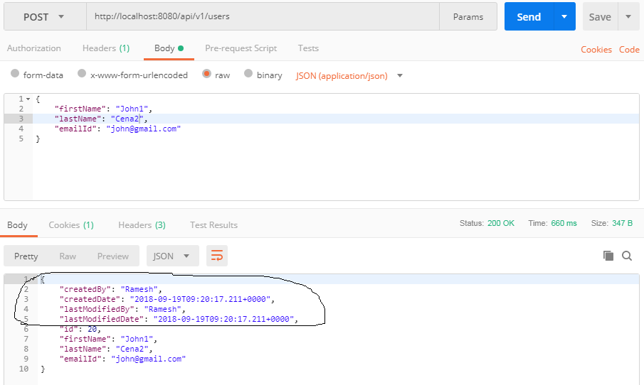](https://3.bp.blogspot.com/-wpR7Bz5fJ04/W6IY_zNigZI/AAAAAAAAD6E/TlVPYJmTssEEHSsaixyhfaBdblHB4V5TACLcBGAs/s1600/post-request.PNG)**

Note that in the above diagram, the response contains audit fields.

**1. Get all Users REST API**

**HTTP Method**: GET  
**RequestURL**: [**http://localhost:8080/api/v1/users**](http://localhost:8080/api/v1/users)  
**Response:**

**[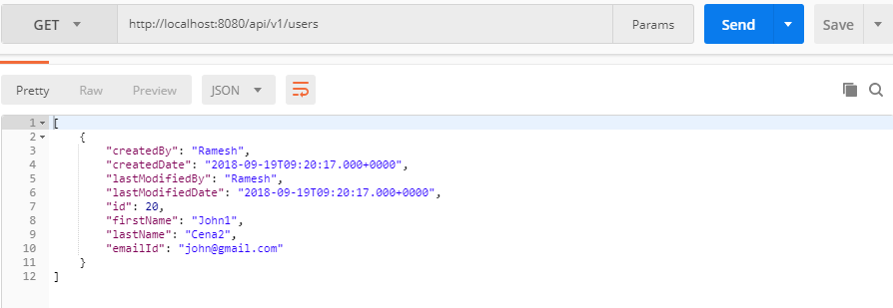](https://4.bp.blogspot.com/-8RI8kLuqlVQ/W6IZXQQIYOI/AAAAAAAAD6M/rpt9DTzKCfM6uLywnNDDb_Ml__8LW5UDwCLcBGAs/s1600/getall-request.PNG)**

**14. Source code on GitHub**

The source code of this article is available on my GitHub repository on [**springboot2-jpa-auditing**](https://github.com/RameshMF/spring-boot-tutorial/tree/master/springboot2-jpa-auditing)

Read 25+ Spring Boot Articles with Source Code on GitHub on [**Spring Boot Tutorial**](http://www.javaguides.net/p/spring-boot-tutorial.html)

[**<< Back to Spring Boot Tutorial**](https://www.javaguides.net/p/spring-boot-tutorial.html)